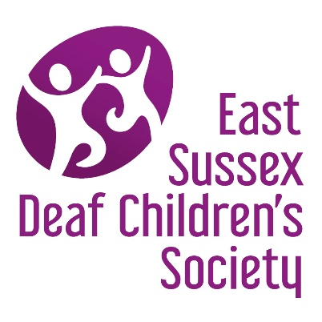

membership registration form

If you are interested in joining the local Deaf Children’s Society or know somebody who might be, please contact any of the following people or complete the form below.
Danny Wheaton  Sherrie Cox | Chairman  Secretary | Mobile: 07976 904947  email: eastsussexdcs@gmail.com  email: eastsussexdcs@gmail.com
Please complete in CAPITAL LETTERS or via computer and return to: eastsussexdcs@gmail.com or via post to East Sussex Deaf Children’s Society, 58 Wannock Gardens, Polegate, East Sussex, BN26 5PA.

First Name |  | Last Name
Address |  | Email Address
 |  | Mobile Number
Postcode
Do you have a deaf or hearing impaired child/ren? |  | Yes / No
Relationship to Child/ren
Your interest in the NDCS

Deaf/Hearing Impaired Child’s Details (if applicable)
First Name |  | Last Name
Date of Birth |  | Gender
Preferred Communication Style
Please turn over …

Details of Siblings (if applicable)
Name
Date of Birth
Does he/she have any hearing loss? |  | Yes / No  Preferred communication style:
Name
Date of Birth
Does he/she have any hearing loss? |  | Yes / No  Preferred communication style:
What support would you like to receive from the society? (events, learning, advice, friendships with other families etc.)
Would you like to receive details of events we are holding? |  | Yes / No
If so, how would you prefer to receive these details? |  | By email In the post

Thank you for completing the registration form. Someone from the Society will be in contact with you shortly to welcome you and explain what we do and answer any specific questions. If you do not want a welcome call, but just want to be signed up to our membership lists and contacted for events, please tick here

Please ‘Like’ our Facebook page as we often share details of events, important information and news via this site.

Email: eastsussexdcs@gmail.com
Website: http://eastsussexdcs.org.uk/
Facebook: https://www.facebook.com/EastSussexDCS

