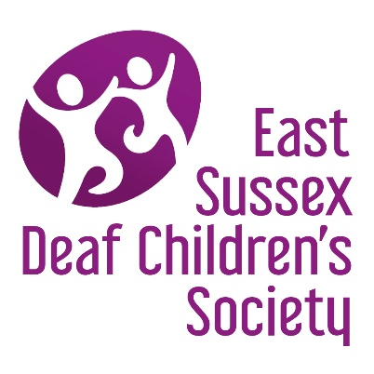
‘SIGNS AND SOUNDS FUND’

Wishes Application form

Applications can be made on behalf of deaf children or young adults aged up to 26 years, who live in East Sussex and who are members of East Sussex Deaf Children’s Society.
Please complete in CAPITAL LETTERS or via computer and return to:

Signsandsoundsfund@gmail.com or Treasurer, East Sussex Deaf Children’s Society, 58 Wannock Gardens, Polegate East Sussex BN26 5PA.

Name of deaf child
Their Address
Their Postcode
Is the child a;
Hearing Aid user |  | Cochlear Implant user |  | Non-aided

Person completing application
First Name |  | Last Name
Address
Post Code |  | Phone number
Email Address
Relationship to child or young person?
Item details
Item Requested
(please be very specific)
Where can it be purchased?
(website details, shop name etc)

Cost? |  | £
How will this benefit the child or young person?
Signature
Date

If we are able to purchase the item for you, we would be grateful if you could send a photo of the child or young person receiving or wearing the item (faces are not essential) so that we can share this with our families and members on facebook and our website.
Thank you for completing the Signs and Sounds Fund, Wishes Application Form. Someone from the Society will be in contact with you shortly regarding the application and may have additional questions to ensure we purchase the correct item.
Please ‘Like’ our Facebook page as we often share details of events, important information and news via this site.
Email: info@eastsussexdcs.org.uk or contact a committee member
Website: http://eastsussexdcs.org.uk/
Facebook: https://www.facebook.com/EastSussexDCS

